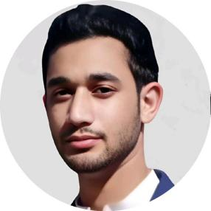 | Muhammad Jalal Khan  Undergraduate Computer Systems Engineer | Front-End Web Developer

📧 jk3434048@gmail.com | 📱 03159035669 | GitHub: Mjalalkhan66 | LinkedIn: Muhammad Jalal Khan
CAREER OBJECTIVE
Enthusiastic Computer Systems Engineering student with strong front-end development skills. Passionate about building responsive, user-friendly applications using modern frameworks and tools.
EDUCATION
B.Sc. Computer Systems Engineering
University of Engineering and Technology (UET), Peshawar
5th Semester
TECHNICAL SKILLS
- HTML, CSS, JavaScript, React, Tailwind CSS
- GitHub & Version Control
- AI Tools & Problem-Solving
PROJECTS
- Personal Portfolio Website
- Modern scientific calculator
- English to english dictionary
- Notes app
- Password Generator
- Todo list
SOFT SKILLS
- Teamwork: Collaborated in university lab projects
- Communication: Good at expressing ideas clearly
- Problem-Solving: Strong analytical and troubleshooting skills
- AI Tools: Effective in using AI for productivity and development

